Description: softserve-univ-logo

Software Requirements Specification

for

SoftServe SSEL “Academy”

Version 1.0

Prepared by Team

SoftServe IT Academy

October 29, 2014

Table of Contents

Revision History 3

1. Introduction 4

1.1 Purpose 4

2. Product features 4

2.2 System Roles 4

3. System features 4

3.1 “Anonymous” role 4

3.2 “Student” role 4

3.2.1 Description 4

3.2.2 "Student Cabinet" page 4

3.2.3 “Courses Info” page 5

3.2.4 "Details Courses" page 6

3.2.5 "My Progress" page 8

3.2.6 "Pass Test" page 8

3.3 “Teacher” role 9

3.3.1 ”Teachers Cabinet” page 9

3.3.2 “New Course” page 10

3.3.3 “Course” page 11

3.3.4 New Module 12

3.3.5 “Module” page 14

3.3.6 “New Topic” page 15

3.4 “Administrator” role 17

3.4.1 ‘Users’ tab 17

3.4.2 ‘Users’ Table 18

3.4.3 ‘Search’ button functionality 18

3.4.4 ‘Edit User’ page 18

3.4.5 ‘Categories’ tab 20

3.4.6 ‘Categories’ Table 22

3.4.7 ‘Search’ button functionality 22

3.4.8 ‘Delete’ link functionality 23

3.4.9 ‘Add category’ page 23

3.4.10 ‘Subjects’ tab 25

3.4.11 ‘Subjects’ Table 26

3.4.12 ‘Search’ button functionality 26

3.4.13 ‘Delete’ link functionality 27

Revision History

|  |  |  |  |
| --- | --- | --- | --- |
| Name | Date | Reasons For Changes | Version |
|  |  |  |  |
|  |  |  |  |
|  |  |  |  |

1. Introduction

1.1 Purpose

The purpose of this project is to provide remote learning for authorized users (“Students”). They will have opportunity to choose courses that they want to learn. Teachers will be able to post and edit custom designed courses, grant access, evaluate their “Students”.

This document contains the functional and non-functional requirements of the application.

2. Product features

2.2 System Roles

Product will contain such roles:

* Anonymous;
* Student;
* Teacher;
* Administrator.

3. System features

3.1 “Anonymous” role

“Anonymous” is unauthorized user that will be able to register is system and become “Student”. In addition, “Anonymous” can view list of categories and courses.

3.2 “Student” role

“Students” are main users of “Academy” application. They will be able to choose what they want to learn and study distantly.

3.2.1 Description

Student has the opportunity to view courses, subscribe, unsubscribe and pass tests. Always on the left side the student sees tabs: "All courses", "Future courses", "Passed courses" and "Present courses". The student can navigate through tabs.

"All courses" - reversing this tab student can see all the possible courses for which have not yet subscribe.

"Future courses" - reversing this tab student can see all courses in the future he have to go.

"Passed courses" - reversing this tab student can see all courses as he have already passed.

"Present courses" - reversing this tab student can see all courses as he is passing now.

3.2.2 "Student Cabinet" page

Logging into your account student see all courses for which he has subscribed.

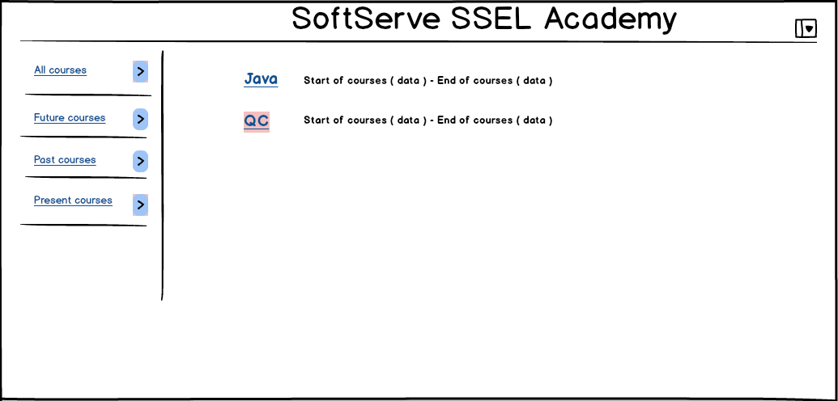

Figure 1. "Student Cabinet" page

Course name displayed as a link clicking on which a student goes to the page "About Course" of the courses.

3.2.3 “Courses Info” page

On this page student see information about the course on which he subscribe "Courses Name", "Description", "Details" and "Unsubscribe" buttons.

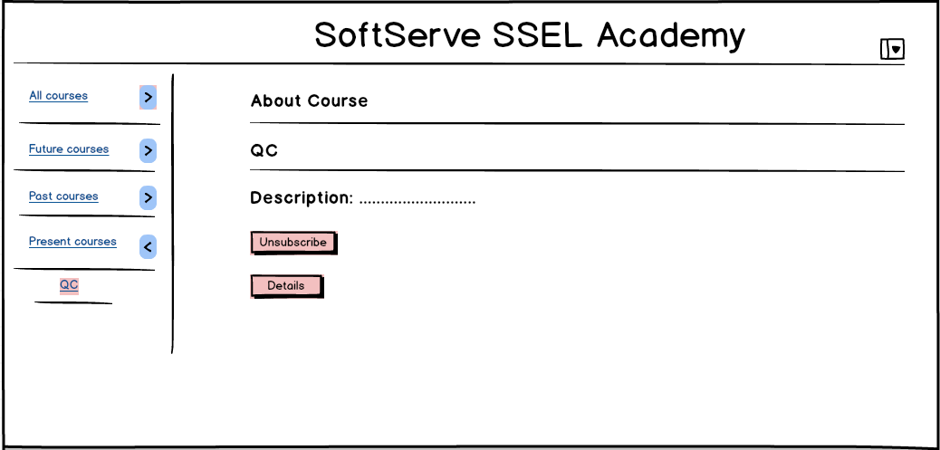

Figure 2. "About Course" page

"Unsubscribe" button - when student click on this button he unsubscribes from the course and has no access to it.

"Details" button - when student click on this button he goes to a page "Details Courses" where can view the complete information about this course.

If the student has not subscribe for a course but has a desire to do that. Student goes to "About Course" page he sees information about this course "Course Name", "Description" and "Details", "Subscribe" buttons.

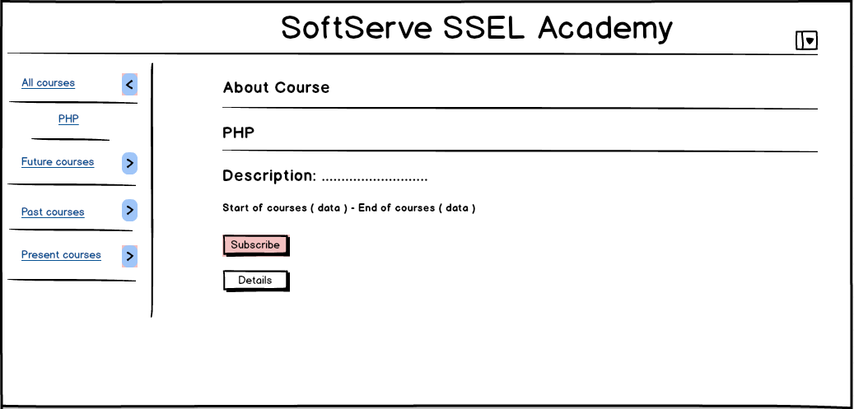

Figure 3. "About Course" page

"Subscribe" button - when student click on this button he subscribe for this course and has access to all materials.

"Details" button - when student click on this button he goes to a page "Details Courses" where can see information about the course but without access to training materials.

If a student wants to find a course to pass, but the course has already started then student can not subscribe a message appears stating that the course has already started (or button is not active ).

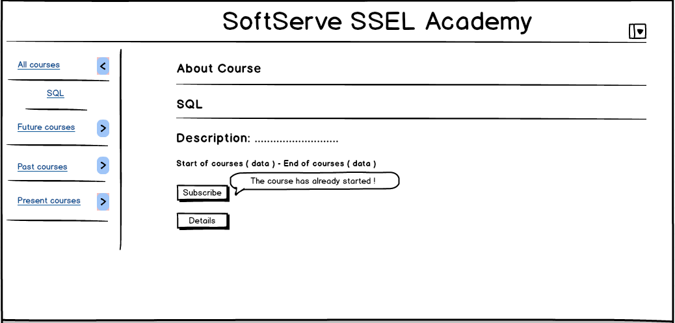

Figure 4. "About Course" page

3.2.4 "Details Courses" page

"Details Courses" page contains detailed information about the course and learning materials.

If the student has subscribe to the course and pressing the button "Details" he will see "Courses Name", "Description", "Instructor", "List References" link, "Test Results" link, the list of course Themes and "My progress".

" List References" link - when clicked goes to a page where student can see a list of relevant literature for this course.

"Test Results" link - when pressed goes to the page where student see the test results to the topics on which he passed tests.

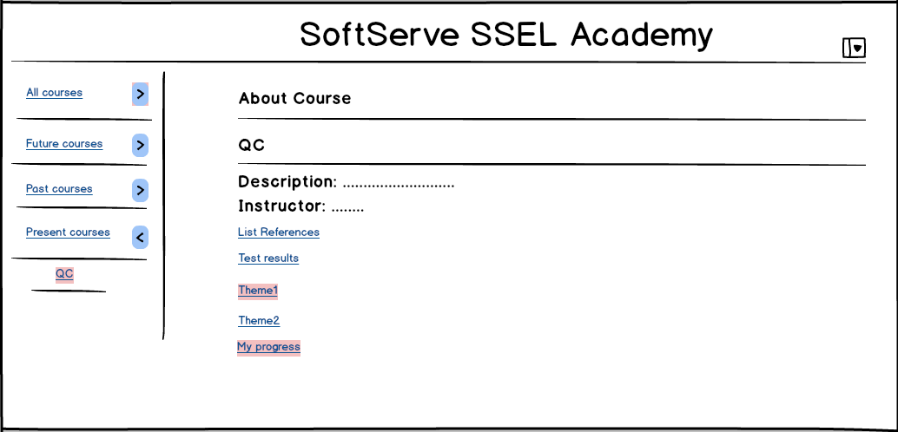

Figure 5. "Details Courses" page

The list of topics displays under the "Test Results" link as a references on Themes materials. When student click on a topic link the window with the topic materials is displayed, if applicable tests in the subject also will be a button "Pass test".

"Pass test" button - when clicked goes to a "Pass Test" page where student pass the test.

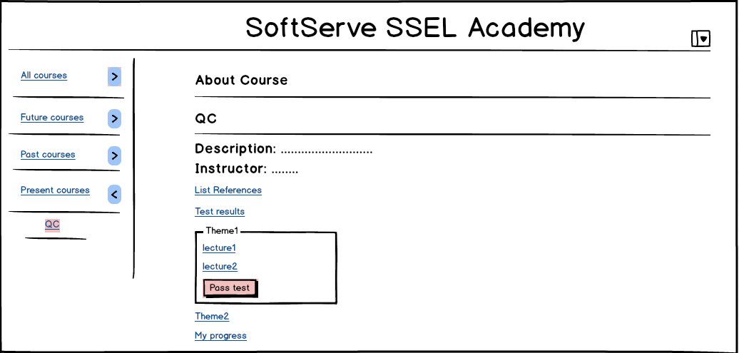

Figure 6. "Details Courses" page

"My progress" link - when clicked goes to a page where student can graphically depicted browse our rating ( in points ) and progress ( how many percent of the course student passed ).

3.2.5 "My Progress" page

On this page student can see in graphical form progress is in percentages what percentage of the course he passed.

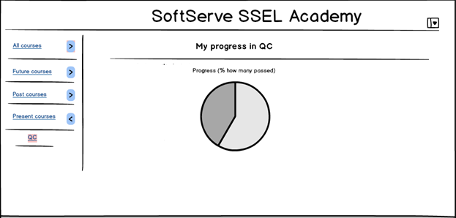

Figure 7. "My Progress" page

3.2.6 "Pass Test" page

On the "Pass Test" page will be shown different types of tests, there are two buttons "Save" and "Exit".

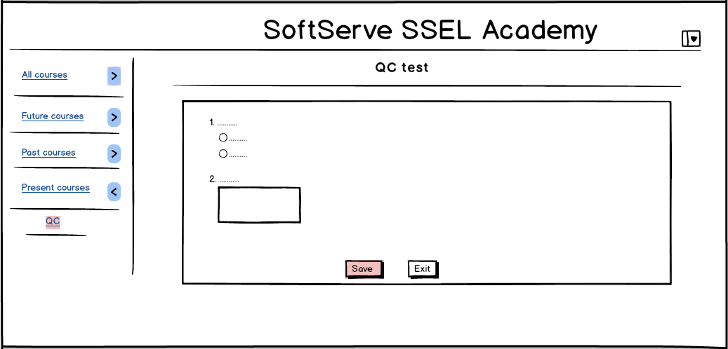

Figure 8. "Pass Test" page

When student presses “Save” button, test answers will be saved and sent to the teacher. Also, a new window will opened, which shows message stating that the test is completed and need to expect results.

"Exit" button - when student press on the button answers are not saved and the student will automatically go to the " Student Cabinet" page.

3.3 “Teacher” role

“Teacher” can create, edit and delete topics, modules and courses, which he created.

3.3.1 ”Teachers Cabinet” page

### C:\Documents and Settings\Admin\Рабочий стол\Mockups\PNG\Cabinet Teacher.png

Figure 1. ‘Teachers Cabinet’

‘Cabinet’ is used for review, sorting, editing and deleting existing courses and for creating new courses. All courses displayed in a table and teacher can sorting existing courses by columns. By default table is sorted by ‘Name course’ ascending rate. The page is depicted in Figure 1.

It consists of the following elements:

* ‘Create’ button. Created new course.
* ‘Delete’ button. Deletes the selected course(s). It prompts teacher to confirm the action with a standard yes/no confirmation dialog. It can be performed on one or more courses at a time.
* ‘Edit’ button. Allows teacher is able to ‘Course’ page, where he can edit or delete modules selected course. When clicking the button ‘Edit’ necessarily should be selected 1 course, otherwise the message should be displayed:” Please select one course”.
* ‘All categories’ allows teacher to view all existing categories and items.

3.3.2 “New Course” page

The page “New Course” consists of ‘Course name’, ‘Describe’, ‘Start date’, ‘End date’ textboxes, ‘Create’ and ‘Cancel’ buttons, dropdown list ‘Category’ with categories. The ’New Course’ page is depicted in Figure 2 below.

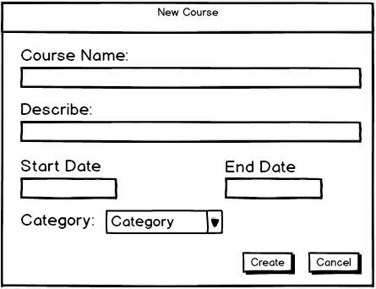

Figure 2

These text boxes have the following format:

1. ‘Course name’: from 1-30 characters mandatory field, has to be unique. Can’t contain reserved characters (=,/, |, \, *, (, ), _, :, ;, #, %, ^, ?, [, ], etc.).
2. ‘Describe’: from 1-250 characters field. This field contain concise describe of what a student will learn in this course. Can contain integer numbers and main reserved characters (=,/, |, \, (, ), _, :, ;, %, !, №, -, .).
3. ‘Start date’, ‘End date’ textbox in date format (DD-MM-YYYY).
4. Dropdown list ‘Category’ consists of existing categories.

Fields validation on the ‘New Course’ page.

If entered data is invalid in:

1. ‘Course name’ textbox:

* user “Teacher” will get an error in red color with the following message when trying to enter more than 30 characters: ‘Course name is too long’.
* user “Teacher” will get an error in red color with the following message when trying to enter reserved characters: ‘Course name can’t contain reserved characters’.
* user “Teacher” will get an error in red color with the following message when trying save existing course name: ‘Course with such name already exists’.
* user “Teacher” will get an error in red color with the following message when trying save with empty field ‘Course name’: ‘Course name can’t be blank’.

1. ‘Describe’ textbox: user “Teacher” will get an error in red color with the following message when trying to enter more than 250 characters: ‘Describe’ is too long’.
2. ‘Start date’, ‘End date’ textbox: user “Teacher” will get an error in red color with the following message when trying to enter data in not date format: ‘Start date must be in the format of date’, ‘End date must be in the format of date’

‘Create’ button accepts entered data, if valid, and stores it to the database.

If click ‘Cancel’ button, return to “Teachers cabinet” page without saved any entered data to the database. ‘Cancel’ button doesn’t store any entered data to the database.

For example, fields should filled to data since as the Figure 3.

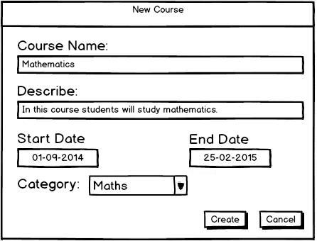

Figure 3

3.3.3 “Course” page

This page shows all modules of the selected course. The page is depicted in Figure 2. Teacher can add new model by clicking ‘Add module’ button. After that page shown in Figure 4 should be opened.

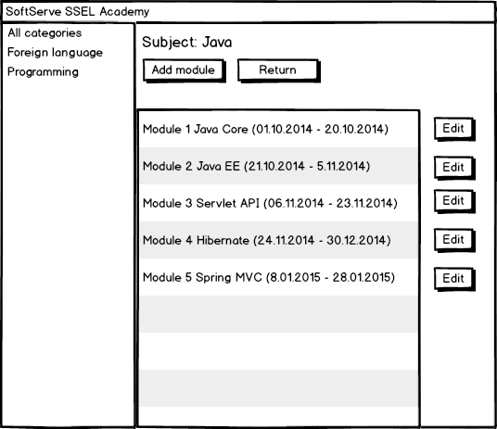

Figure 2. ‘Course’ page

Clicking on button ‘Return’ displayed ‘Teachers Cabinet’ page with default views.

To edit a module, teacher must click ‘Edit’ button next to the appropriate module. After that, should be displayed ‘Module’ page, depicted in Figure 3.

3.3.4 New Module

To create a module, the teacher should click on the "Add module" button on “Courses” page.

The page “New Module” consists of ‘Module name’, ‘Describe’, ‘Start date’, ‘End date’ textboxes, ‘Create’ and ‘Cancel’ buttons, dropdown list ‘Course’ with existing courses. The ’New Module’ page is depicted in Figure 4 below.

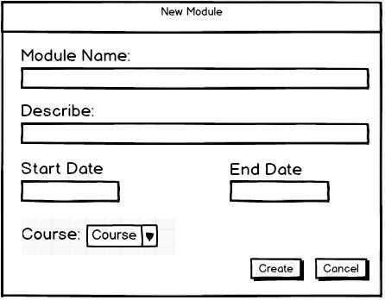Figure 4

These text boxes have the following format:

1. ‘Module name’: from 1-30 characters mandatory field, has to be unique for this course. Can’t contain reserved characters (=,/, |, \, *, (, ), _, :, ;, #, %, ^, ?, [, ], etc.).
2. ‘Describe’: from 1-250 characters field. This field contain concise describe of what a student will learn in this course. Can contain integer numbers and main reserved characters (=,/, |, \, (, ), _, :, ;, %, !, №, -, .).
3. ‘Start date’, ‘End date’ textbox in date format (DD-MM-YYYY).
4. Dropdown list ‘Course’ consists of existing courses.

Fields validation on the ‘New Module’ page.

If entered data is invalid in:

1. ‘Module name’ textbox:

* user “Teacher” will get an error in red color with the following message when trying to enter more than 30 characters: ‘Module name is too long’.
* user “Teacher” will get an error in red color with the following message when trying to enter reserved characters: ‘Module name can’t contain reserved characters’.
* user “Teacher” will get an error in red color with the following message when trying save existing module name for this course: ‘Module with such name already exists for this course’.
* user “Teacher” will get an error in red color with the following message when trying save with empty field ‘Module name’: ‘Module name can’t be blank’.

1. ‘Describe’ textbox: user “Teacher” will get an error in red color with the following message when trying to enter more than 250 characters: ‘Describe’ is too long’.
2. ‘Start date’, ‘End date’ textbox: user “Teacher” will get an error in red color with the following message when trying to enter data in not date format: ‘Start date must be in the format of date’, ‘End date must be in the format of date’

‘Create’ button accepts entered data, if valid, and stores it to the database.

If click ‘Cancel’ button, return to “Courses” page without saved any entered data to the database. ‘Cancel’ button doesn’t store any entered data to the database.

3.3.5 “Module” page

On this page displayed all topics and tests, which contained in the selected modules. Functionality this page allows teacher to add topic, to add test, edit or delete selected topic(s) or test(s).

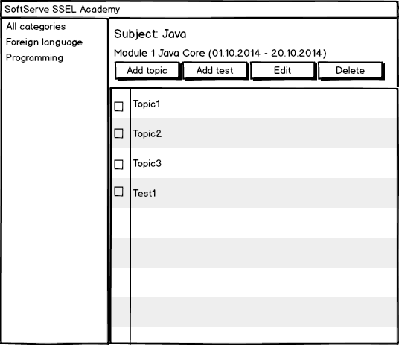

Figure 3. ‘Module’ page

To remove the topic or test teacher must select one or more topics or (and) test(s) and click ‘Delete’ button. After that should be displayed message: “Are you sure you want to delete the selected item(s)?” Pressing the ‘Yes’ button in the confirmation dialog will delete the selected topic(s) and test(s). Choosing ‘No’ will leave the remaining topic(s) and comments undeleted and unselected.

When clicking the button ‘Edit’ necessarily should be selected 1 topic or test, otherwise the message should be displayed:” Please select one topic or test”.

Click on ‘Edit’ button opened ‘Edit topic’ page, where teacher can edit selected topic or test.

3.3.6 “New Topic” page

To create a topic, the teacher should click on the "Add Topic" button on “Courses” page.

The page “New Topic” consists of ‘Topic name’, ‘Topic Order’ textboxes, ‘Enable’, ‘Disable’ radiobuttons, textbox field ‘Body’ with panel for text editing, dropdown list ‘Select module’ with existing modules, ‘Create’ and ‘Cancel’ buttons. The ’New Topic’ page is depicted in Figure 5 below.

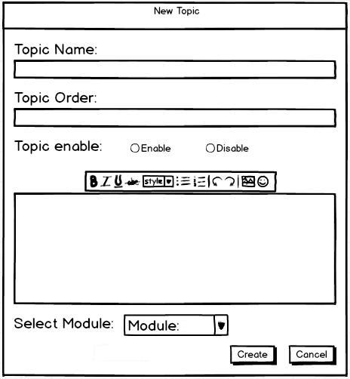

Figure 5

These text boxes have the following format:

1. ‘Topic name’: from 1-30 characters mandatory field has to be unique for this module. Can’t contain reserved characters (=,/, |, \, *, (, ), _, :, ;, #, %, ^, ?, [, ], etc.).
2. ‘Topic order’: from 1-250 characters field. This field contain concise describe of what a student will learn in this topic. Can contain numbers and main reserved characters (=,/, |, \, (, ), _, :, ;, %, !, №, -, .).
3. ‘Enable’, ‘Disable’ radiobuttons allows user “Teacher” enabled topic.
4. ‘Body’ field: from 1-1500 characters without links, user “Teacher” can write text, record useful links for students on this topic.
5. Dropdown list ‘Select Module’ consists of existing modules.

Fields validation on the ‘New Course’ page.

If entered data is invalid in:

1. ‘Topic name’ textbox:

* user “Teacher” will get an error in red color with the following message when trying to enter more than 30 characters: ‘Course name is too long’.
* user “Teacher” will get an error in red color with the following message when trying to enter reserved characters: ‘Topic name can’t contain reserved characters’.
* user “Teacher” will get an error in red color with the following message when trying save existing topic name for this module: ‘Topic with such name already exists for this module’
* user “Teacher” will get an error in red color with the following message when trying save with empty field ‘Topic name’: ‘Topic name can’t be blank’.

1. ‘Topic order’ textbox: user “Teacher” will get an error in red color with the following message when trying to enter more than 250 characters: ‘Topic order is too long’.
2. One of the radiobuttons: ‘Enable’, ‘Disable’, should be included.
3. ‘Body’ field: user “Teacher” will get an error in red color with the following message when trying to enter more than 1500 characters: ‘Topic order is too long’.

‘Create’ button accepts entered data, if valid, and stores it to the database.

If click ‘Cancel’ button, return to “Courses” page without saved any entered data to the database. ‘Cancel’ button doesn’t store any entered data to the database.

All errors in red color should look like:

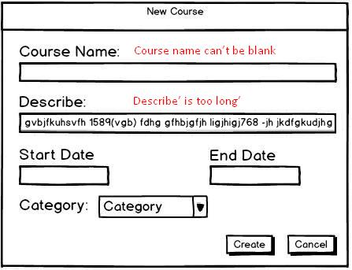

3.4 “Administrator” role

Administrator sees the following tabs: ‘Users’, ‘Categories’ and ‘Subjects’. ‘Users’ tab should be opened by default. Administrator can switch between tabs, clicking on the necessary one. Tabs don’t revert to default state after switching between them.

3.4.1 ‘Users’ tab

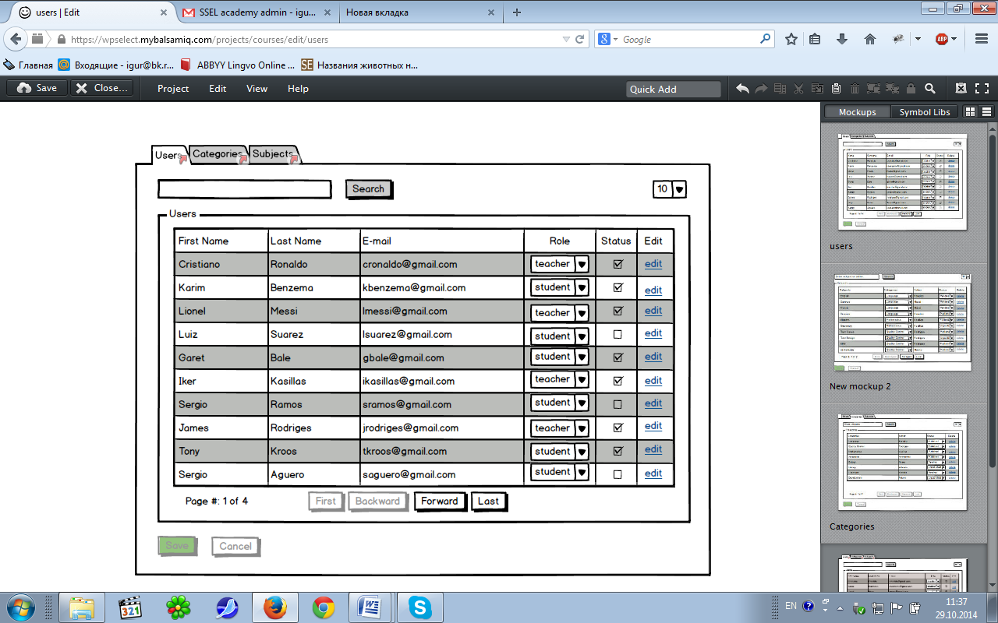

Figure 1. ‘Users’ tab

The ‘Users’ tab allows Administrator to view information about all registered users. Administrator can change ‘Role’, ‘Status’, or edit users. The tab is depicted in Figure 1.

The ‘Users’ tab has following options:

1. Search button allows to do search when information is filled in a text box. Text box for entering search information is empty by default with following format: 15 characters, case insensitive.
2. ‘First’ returns the information about users from the first page in the ‘Users’ grid. The ‘First’ button should be disabled if current page is the 1st one.
3. ‘Last’ returns the information about users from the last page in the ‘Users’ grid. ‘Last’ button should be disabled if current page is the last one.
4. ‘Backward’ returns the information about users from the page by one step back. ‘Backward’ button should be disabled if current page is the 1st one.
5. ‘Forward’ returns the information about users from the page by one step forward. ‘Forward’ button should be disabled if current page is the last one.
6. ‘Show 10 users’ drop-down list. ‘Show 10 users’(displayed ‘10’ by default) means that for the present moment only 10 users are shown per page. Clicking on this drop-down list forces showing possible variants to choose: ‘10’, ‘20’, ‘50’.
7. Page#: label shows current page number and total pages.For example: Page #: 1 of 3 indicates that user is on first page, totally 3 pages are present.
8. ‘Save’ button accepts changed data, and stores it to the database, and leaves Administrator on the ‘Users’ tab on preserved current page. ‘Save’ button is disabled by default. Any changes made by Administrator in the ‘Users’ grid make ‘Save’ button enabled. After successful saving ‘Save’ button should be disabled.
9. ‘Cancel’ button doesn’t store any changed data to the database and leaves administrator on the ‘Users’ tab on preserved current page. Is disabled by default. Any changes made by Administrator in the ‘Users’ grid make ‘Cancel’ button enabled. After successful cancel ‘Cancel’ button should be disabled.

3.4.2 ‘Users’ Table

Administrator can view information about existing users in a table. Table with such labels of columns: ‘First Name’, ‘Last Name’, ‘E-mail’, ‘Role’, ‘Status’, ‘Edit’. The list of users will be shown in the order of their creation by default, new created on top. ‘Role’ are the drop-down lists, which show what role a user has from existing roles in the database. ‘Status’ are the checkboxes, which show whether user has a permission to access the system. Unmarked checkboxes mean that access is denied.

‘Edit’ are links, which allow to edit user on ‘Edit user’ page .

3.4.3 ‘Search’ button functionality

‘Search’ can be done by ‘First Name’, ‘Last Name’, ‘E-mail’ using search information which is entered into text box field (empty by default) after clicking ‘Search’ button.

User will get an error in red color with the following message when trying to enter more than 15 characters: ‘Maximum length of search text is 15 characters’ below text field.

If users with chosen values don’t exist in the system a table with all columns, but without any information about users should appear. If no information is entered into text box a default users grid with data appear after pressing ‘Search’ button.

3.4.4 ‘Edit User’ page

The ‘Edit User’ page allows Administrator to edit information about existing user. The page consists of ‘First Name’, ‘Last Name’, ‘Password’, ‘Confirm Password’, ‘Email Address’ text boxes; ‘Role’ group box with 3 radio buttons(‘Administrator’, ‘Teacher’, ‘Student’) with possibility to choose only one role; ‘Save’ and ‘Cancel’ buttons. Default states of all controls look like as mockup (Figure 2). All controls should contain information of a chosen user, except ‘Password’ and ‘Confirm Password’ fields (they are empty).

The ‘Edit User’ page is depicted in Figure 2 below.

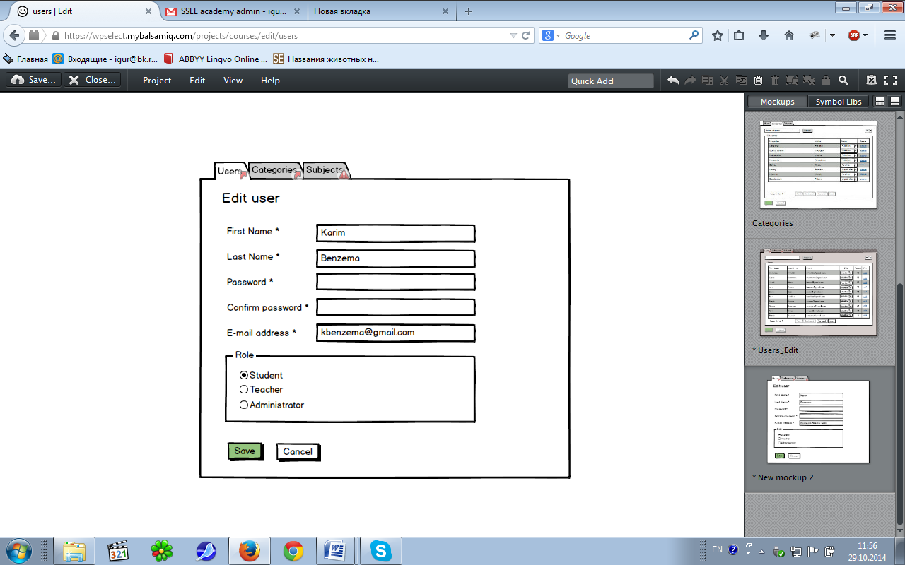

Figure 2. ‘Edit User’ page

When editing user, this action simply updated the database for the user that is currently being edited based on the data entered and then leaves the fields displaying the entered data.

Administrator must fill in ‘Password’ and ‘Confirm Password’ fields before saving. Administrator can use old (password is not changed) or enter new password (new password will be stored).

‘Save’ button accepts entered data, if valid, and stores it to the database, and returns user to main page on the ‘Users’ tab.

‘Cancel’ button doesn’t store any entered data to the database and returns user to the main page on the ‘Users’ tab.

These text boxes have the following format:

* ‘First Name’, ‘Last Name’: from 1 to 13 characters mandatory field, case sensitive. Can’t contain reserved characters (=,/, |, \, *, (, ), _, :, ;, #, %, ^, ?, [, ], etc.).
* ‘Password’: Symbols entered in ‘Password’ field are transformed in asterisks at once after entering. Cannot be shorter than 4 characters and longer than 10 mandatory fields.
* ’Confirm Password’: Symbols entered in ’Confirm Password’ field are transformed in asterisks at once after entering. ‘Confirm Password’ should be the same as entered data in ‘Password’ text box.
* ‘Email Address’: mandatory field, according following format: local-part@domain.com

**Fields validation on the ‘Edit User’ page.**

If entered data is invalid in:

* ’First Name’/’Last Name’ text boxes: Administrator will get an error in red color with the following message when trying to enter more than 13 characters: ‘First name is too long’ / ‘Last Name is too long’ on the right side of corresponding fields.

Administrator will get an error in red color with the following message when trying to enter reserved characters: ‘First name cannot contain reserved characters’ / ‘Last Name cannot contain reserved characters’ on the right side of corresponding fields.

When Administrator doesn’t enter any data in this field after clicking ‘Save’ button the next message appears: ‘First name cannot be blank’ / ‘Last name cannot be blank’ on the right side of corresponding fields.

* ‘Password’/’Confirm Password’ text boxes: Administrator will get an error in red color with the following message when trying to enter less than 4 or more than 10 symbols in ‘Password’ field: ‘Password cannot be shorter than 4 and longer than 10 characters’ on the right side of corresponding fields.

When Administrator doesn’t enter any data in ‘Password’ field after clicking ‘Save’ button the next message appears: ‘Password cannot be blank’ on the right side of ‘Password’ field.

If entered data in ‘Password’ field isn’t the same as entered data in ‘Confirm Password’ the next message appears: ‘Confirm password has to be equal to password’ on the right side of ‘Confirm Password’ field.

* ‘Email Address’: will get an error in red color with the following message: ‘You should use valid email address’ on the right side of ‘Email Address’ field.

When Administrator doesn’t enter any data in this field after clicking ‘Save’ button the next message appears: ‘Email Address cannot be blank’.

‘Save’ button accepts entered data, if valid, and stores it to the database, and returns Administrator to main page on the ‘Users’ tab.

‘Cancel’ button doesn’t store any entered data to the database and returns Administrator to the main page on the ‘Users’ tab.

3.4.5 ‘Categories’ tab

The ‘Categories’ tab allows Administrator to view information about all created categories. Administrator can change ‘Status’, add or delete categories.

The tab is depicted in Figure 3.

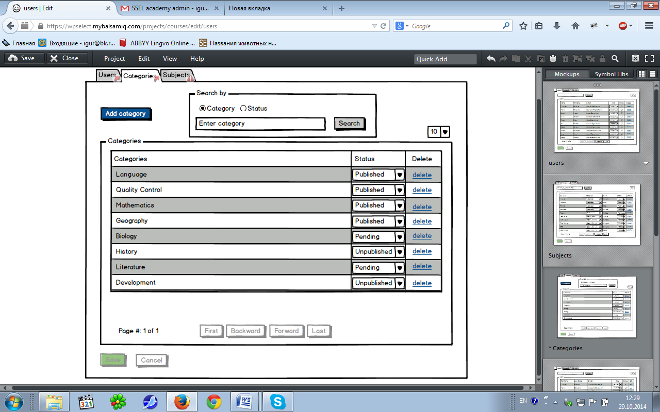

Figure 3. ‘Categories’ tab

The ‘Categories’ tab has following options:

1. Search button allows to do search when information is filled in a text entry box. Text box for entering search information has text “Enter category” by default with following format: 15 characters, case insensitive. When text cursor is set in the text entry box the text “Enter category” disappears. Administrator can search by category or status, choose between 2 radiobuttons ‘Category’ and ‘Status’. Radiobutton ‘Category’ is checked by default. If administrator choses ‘Status’ radiobutton text box for entering search information will have text “Enter status”, which would disappear when text cursor is set in the text entry box.
2. ‘First’ returns the information about categories from the first page in the ‘Categories’ grid. The ‘First’ button should be disabled if current page is the 1st one.
3. ‘Last’ returns the information about categories from the last page in the ‘Categories’ grid. ‘Last’ button should be disabled if current page is the last one.
4. ‘Backward’ returns the information about categories from the page by one step back. ‘Backward’ button should be disabled if current page is the 1st one.
5. ‘Forward’ returns the information about categories from the page by one step forward. ‘Forward’ button should be disabled if current page is the last one.
6. ‘Show 10 categories’ drop-down list. ‘Show 10 categories’(displayed ‘10’ by default) means that for the present moment only 10 categories are shown per page. Clicking on this drop-down list forces showing possible variants to choose: ‘10’, ‘20’, ‘50’.
7. Page#: label shows current page number and total pages.For example: Page #: 1 of 3 indicates that administrator is on first page, totally 3 pages are present.
8. ‘Save’ button accepts changed data, and stores it to the database, and leaves Administrator on the ‘Categories’ tab on preserved current page. ‘Save’ button is disabled by default. Any changes made by Administrator in the ‘Categories’ grid make ‘Save’ button enabled. After successful saving ‘Save’ button should be disabled.
9. ‘Cancel’ button doesn’t store any changed data to the database and leaves administrator on the ‘Categories’ tab on preserved current page. Is disabled by default. Any changes made by Administrator in the ‘Categories’ grid make ‘Cancel’ button enabled. After successful cancel ‘Cancel’ button should be disabled.
10. ‘Add category’ button allows to add category on ‘Add category’ page .

3.4.6 ‘Categories’ Table

Administrator can view information about existing categories in a table. Table with such labels of columns: ‘Categories’, ‘Status’, ‘Delete’. The list of categories will be shown in the order of their creation by default, new created on top. ‘Status’ are the drop-down lists, which show what status a category has from existing statuses in the database (‘Pending’, ‘Published’, ’Unpublished’). ‘Delete’ are links, which allow to delete categories.

3.4.7 ‘Search’ button functionality

‘Search’ can be done by ‘Category’ or ‘Status’ using radiobuttons and search information which is entered into text box field (contains “Enter category” by default) after clicking ‘Search’ button.

Administrator will get an error in red color with the following message when trying to enter more than 15 characters: ‘Maximum length of search text is 15 characters’ below text field.

If categories with entered values don’t exist in the system a table with all columns, but without categories should appear. If no information is entered into text box a default categories grid with data appear after pressing ‘Search’ button.

3.4.8 ‘Delete’ link functionality

Administrator can delete category by clicking ‘Delete’ link. If Administrator deletes a category, dialog window (Figure 4) will appear with the following message: ‘The category will be deleted from the List of Categories. Are you sure you want to proceed?’. Pressing ‘OK’ button in dialog window will delete the chosen category from the List of Categories. All subjects assigned to deleted category are set categories ‘None’ and status ‘Pending’. Choosing ‘Cancel’ button, the system will cancel the operation of deletion.

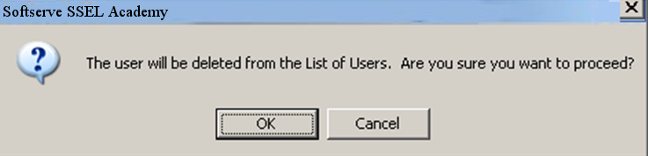

Figure 4. ‘Delete’ confirmation dialog box

3.4.9 ‘Add category’ page

The ‘Add category’ page allows Administrator to create a new category. The page consists of ‘Category’ text box, ‘Status’ group box with 2 radio buttons(‘Published’(default value), ‘Unpublished’) with possible to choose only one role; ‘Save’ and ‘Cancel’ buttons. Default states of all controls look like as Figure 5 below.

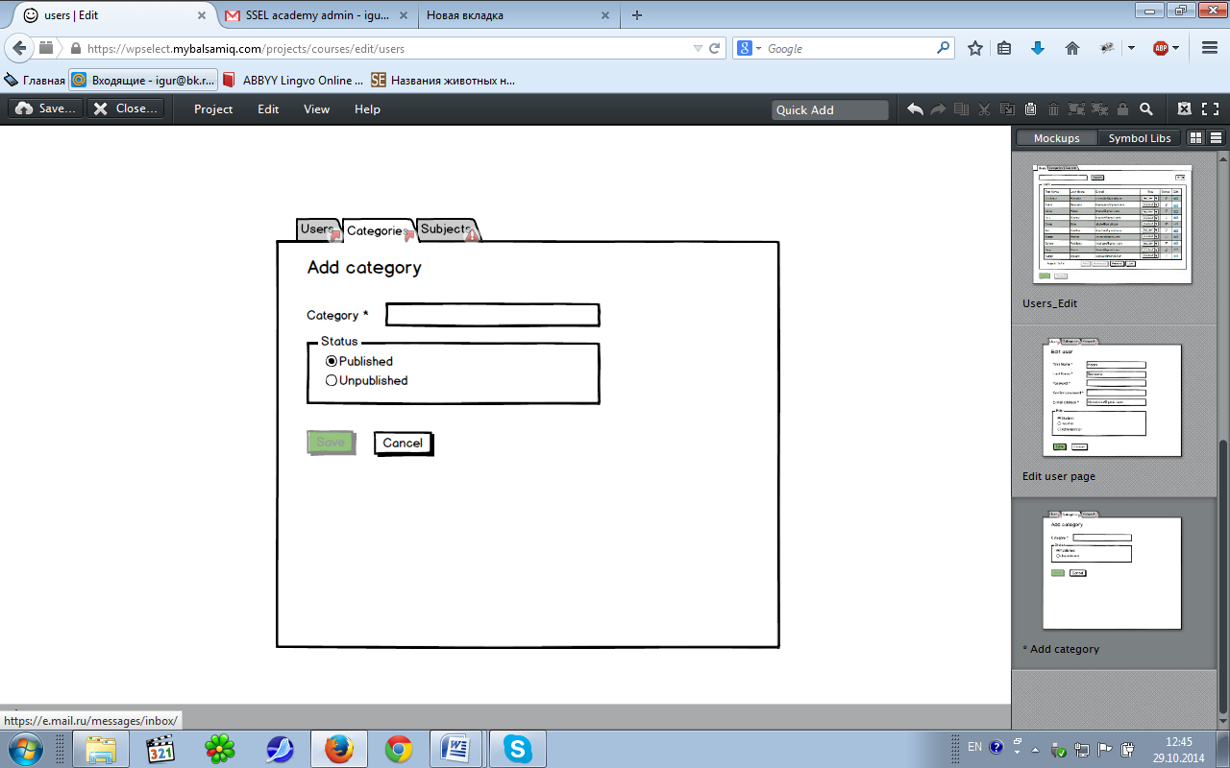

Figure 5. ‘Add category’ page

This text box has the following format:

* ‘Category’: from 1 to 15 characters mandatory field, case insensitive has to be unique. Can’t contain reserved characters (=,/, |, \, *, (, ), _, :, ;, #, %, ^, ?, [, ], etc.). If administrator enters in the ‘Category’ field existing category, the error message appears with the following text: ‘Category already exists’ on the right side of 'Category’ field.

**Fields validation on the ‘Add category’ page.**

If entered data is invalid in:

* ‘Category’ text box: Administrator will get an error in red color with the following message when trying to enter more than 15 characters: ‘Category name is too long.’ on the right side of corresponding field.

Administrator will get an error in red color with the following message when trying to enter reserved characters: ‘Category name cannot contain reserved characters’ on the right side of corresponding field.

‘Save’ button accepts entered data, if valid, and stores it to the database, and returns administrator to main page on the ‘Categories’ tab. Is disabled by default. It become enabled if administrator enters some value in ‘Category’ field.

‘Cancel’ button doesn’t store any entered data to the database and returns administrator to the main page on the ‘Categories’ tab. Is enabled by default.

3.4.10 ‘Subjects’ tab

The ‘Subjects’ tab allows Administrator to view information about all created subjects. Administrator can change ‘Categories’, ‘Status’, or delete subjects.

The tab is depicted in Figure 6.

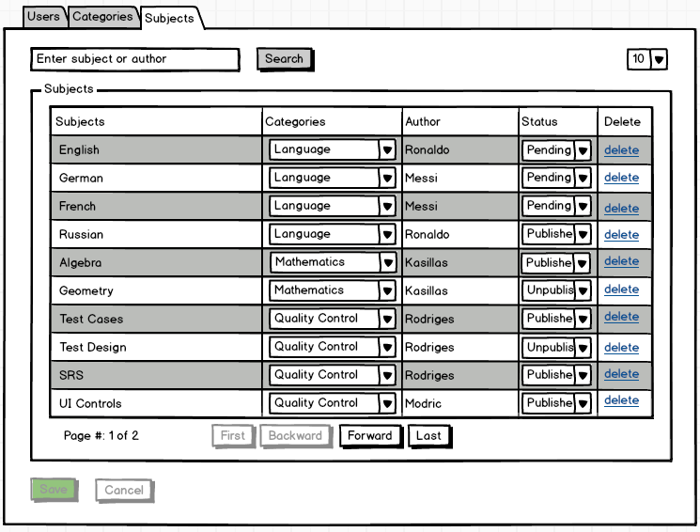 Figure 6. ‘Categories’ tab

The ‘Categories’ tab has following options:

1. Search button allows to do search when information is filled in a text entry box. Text box for entering search information has text “Enter subject or author” by default with following format: 15 characters, case insensitive. When text cursor is set in the text entry box the text “Enter subject or author” disappears.
2. ‘First’ returns the information about subjects from the first page in the ‘Subjects’ grid. The ‘First’ button should be disabled if current page is the 1st one.
3. ‘Last’ returns the information about subjects from the last page in the ‘Subjects’ grid. ‘Last’ button should be disabled if current page is the last one.
4. ‘Backward’ returns the information about subjects from the page by one step back. ‘Backward’ button should be disabled if current page is the 1st one.
5. ‘Forward’ returns the information about subjects from the page by one step forward. ‘Forward’ button should be disabled if current page is the last one.
6. ‘Show 10 subjects’ drop-down list. ‘Show 10 subjects’(displayed ‘10’ by default) means that for the present moment only 10 subjects are shown per page. Clicking on this drop-down list forces showing possible variants to choose: ‘10’, ‘20’, ‘50’.
7. Page#: label shows current page number and total pages.For example: Page #: 1 of 3 indicates that administrator is on first page, totally 3 pages are present.
8. ‘Save’ button accepts changed data, and stores it to the database, and leaves Administrator on the ‘Subjects’ tab on preserved current page. ‘Save’ button is disabled by default. Any changes made by Administrator in the ‘Subjects’ grid make ‘Save’ button enabled. After successful saving ‘Save’ button should be disabled.
9. ‘Cancel’ button doesn’t store any changed data to the database and leaves administrator on the ‘Subjects’ tab on preserved current page. Is disabled by default. Any changes made by Administrator in the ‘Subjects’ grid make ‘Cancel’ button enabled. After successful cancel ‘Cancel’ button should be disabled.

3.4.11 ‘Subjects’ Table

Administrator can view information about existing subjects in a table. Table with such labels of columns: ‘Subjects’, ‘Categories’, ‘Author’, ‘Status’, ‘Delete’. The list of subjects will be shown in the order of their creation by default, new created on top.

‘Categories’ are the drop-down lists, which show what category a subject is assigned to from existing categories in the database. ‘Status’ are the drop-down lists, which show what status a subject has from existing statuses in the database (‘Pending’, ‘Published’, ’Unpublished’). ‘Delete’ are links, which allow to delete subjects.

3.4.12 ‘Search’ button functionality

‘Search’ can be done by ‘Subject’ or ‘Author’ using search information which is entered into text box field (contains “Enter subject or author” by default) after clicking ‘Search’ button.

Administrator will get an error in red color with the following message when trying to enter more than 15 characters: ‘Maximum length of search text is 15 characters’ below text field.

If subjects with entered values don’t exist in the system a table with all columns, but without subjects should appear. If no information is entered into text box a default subjects grid with data appear after pressing ‘Search’ button.

3.4.13 ‘Delete’ link functionality

Administrator can delete subject by clicking ‘Delete’ link. If Administrator deletes a subject, dialog window (Figure 4) will appear with the following message: ‘The subject will be deleted from the List of Subjects. Are you sure you want to proceed?’. Pressing ‘OK’ button in dialog window will delete the chosen subject from the List of Subjects. Choosing ‘Cancel’ button, the system will cancel the operation of deletion.